**Job Searching Web Application**

**Requirements:**

We need to build software for Quick Job Corporation. The application will have following features:

* In registration process people can be register as user and company but Superadmin can register Another people as operator.
* Before confirm registration user have verify their email after that they can set their password.
* If user forget password the have give email number then they will get new password setting option.
* There will be four types of user like Superadmin, Operator, Company and Job-seeker.
* Superadmin can see and edit every table like user, all field and table of CV making and job post but he can only see the role list. Superadmin can edit data and get information of all about.
* Operator can see and edit every table like user, all field and table of CV making and job post but he can only unable to see the role list and role edit page. One more is operator will not be able to see and edit user password and personal information.
* Company can upload a job post see how many Job-seeker applied in their company, who applied and they can also see the CV of Job-seeker.
* Job-seeker can see who many jobs are available, what types of jobs are available, upload and create their CV after that they will be able to apply in jobs.

**Brainstorming Diagram**

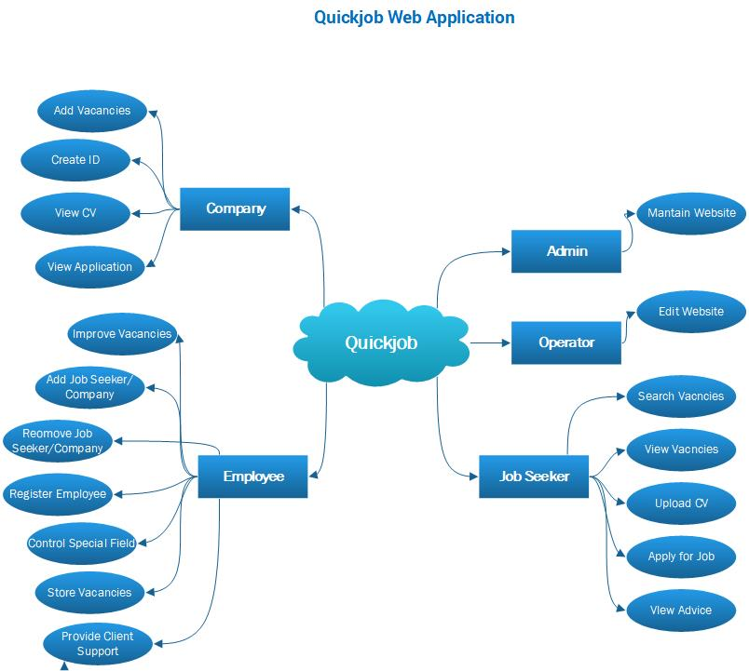

**Use Case Diagram**

